

**ACCT421 Analytics for Value Investing**

**AY2019-20 Term 2**

**Group Project Report**

**G1**

**Prepared for:**

**Prof. Andrew Lee**

**Prepared by:**

**KEITH NG JO HANN**

**LIM WEI JIE**

**SENG EN HUI**

**TAN XIN AN SAMUEL**

Table of Contents

Literature Review 3

Source of Data 3

1. Methodology (Portfolio Strategy) 4

A. Screening for High Gross Margin firms 4

B. Fama-French (Size and Value) 4

C. Choosing high F-score companies 5

D. Portfolio Formation 6

E. Limitations 7

*Regression Analysis on Variables* 7

2. Portfolio Optimisation 7

A. Markowitz Modern Portfolio Theory 7

B. Methodology of Optimising Portfolio: 8

*Mean-Variance Optimisation:* 8

*Maximising Sharpe Ratio Utility Function* 9

C. Back-testing Methodology 10

3. Results 11

4. Recommendations 12

References 13

Appendix 15

# Literature Review

The project was designed to select value stocks by using gross profit margin, market capitalisation, book-to-market ratio and looking at that respective F-Scores. After narrowing down on the selected value stocks, we then formed the portfolio by optimising the Sharpe ratio. This was followed by a sentiment analysis done on major financial news articles over a span of 13-years, to understand how value stocks react to market sentiments which involves using natural language processing tools, like Vader and Textblob, to measure market sentiments.

# Source of Data

The data was obtained from Compustat over the span of 15 years (March 2003 - March 2018). Both annual accounting data and monthly stock returns were downloaded over the same period for the tradable universe of U.S. companies. We believe this period to be a comprehensive and accurate representation of the economic cycle. For both data sets, a condition was applied to remove any financial institutions (GSECTORS! = 40). This allows us to adjust for high leverage, which would be common in financial institutions (but not in non-financial institutions). Our strategy will further incorporate stock picking criteria which will be used in the yearly formation of our portfolio.

The firms we narrowed down consisted of numerous firms with varying fiscal year ends. As such, to normalise this factor, the following assumptions were made:

1. Fiscal Year-ends end between 1st of April to 31st of March.
2. Portfolio formation/rebalancing will commence on 30th June each year.
3. Annual accounting data will hence be matched with monthly stock returns, thus creating a gap which varies across firms. We also created a ‘lag’ to allow for the publishing of accounting data.

For the formation of the portfolio, prices were obtained from the Yahoo Finance API.

# 1. Methodology (Portfolio Strategy)

## A. Screening for High Gross Margin firms

Robert Novy-Marx, in his paper, “The other side of value: The gross profitability premium”, found that the Gross Profit margin (gross profits over total assets) has roughly the same power as book-to-market in predicting stock returns. High gross margins are generally associated with good growth stocks and these growth stocks have a low book-to-market ratio. This negative correlation between gross margin and book-to-market is documented in Table 2 of the paper. Novy-Marx also posits that this negative correlation could improve value strategies if the investor controlled for profitability and tests this hypothesis. In Table 4 of his paper, he shows that within each size quintile, the returns on high profitability firms are significantly higher than those of low profitability firms.

## B. Fama-French (Size and Value)

In the traditional Capital Asset Pricing Model (Re= Rf +(Rm-Rf)*Beta) by Sharpe, Linter and Black (SLB), it is argued that expected returns on securities are a positive linear function in relation to the market betas (systematic risk). However, research has shown that the relation between beta and average return is becoming weaker in recent years (1963-1990). This is supported by tests conducted by Fama and French, whose results do not support basic prediction of CAPM, i.e. a positive relationship between market beta and average returns. This could possibly be because other explanatory variables are correlated with true betas, which therefore obscure the relationship between returns and measured betas (Fama & French, 1992). Instead, Fama and French’s paper (1992) aimed to suggest and show that stock risks were multidimensional, hence justifying that the CAPM could be further built upon by adding several factors, such as the size factor and the ratio of the book value of common equity to its market value (BE/ME). This gives rise to the 3-factor model (Re = Rf + B(rm-rf) +B2(SMB) + B3(HML) + e). Other researchers have also leaned towards comparing the coefficient of determination (r^2) between the two models. They subsequently found that the adjusted r^2 of the 3-factor model has a higher value than that of CAPM, which would mean that the former is better in predicting variation in excess return (Sattar, 2017).

Fama and French tested their hypothesis by running a grouped regression from July 1963 to December 1990, showing significantly high t-statistics and an overall stronger negative relationship between average returns and size. In their research, the size of the firms was analysed by looking at the Market Equity (ME) or the market capitalisation, which was calculated by using a stock's price times shares outstanding. It was found that average returns on small (low ME) stocks were very high given their Beta estimates. The opposite held true for the average returns on large stocks (High ME). This could be because of a higher probability for large stocks to have stronger and less risky prospects, thus giving rise to lower-than-average stock returns. Vice versa, average returns of small stocks (low ME) are similarly expected to be higher.

From Fama and French’s results, we also observe a strong positive relationship between average returns and book-to-market equity. High book-to-market stocks, also known as value stocks, have been shown to perform better than low book-to-market stocks. By comparing the t-statistics between the Value (5.71) and Size (-2.58) factors from the monthly regressions of returns, Fama-French further explains that the book-to-market relation is stronger than the size effect. Moreover, it has been shown that the spread between the highest and lowest value portfolios was twice as large as the spread between the smallest and largest size portfolios, signifying its importance.

Both size and value variables are persistently statistically significant regardless of the inclusion of other explanatory variables are in the regressions. In addition, the relationships between returns and size/value are so clearly demonstrated and defined. We will thus be adopting both size and value factors as our screening criteria/signals as part of our strategy.

## C. Choosing high F-score companies

Lastly, we utilised the F-Score to form our portfolio. Piotrowski had refined the concept that high book-to-market firms tend to earn higher returns than low book-to-market firms. As the average high book-to-market firm is financially distressed (Fama and French, 1995), Piotrowski found that he could further divide high book-to-market firms into high quality and low-quality firms with his F-Score. This strategy worked well because high book-to-market firms tended to be value firms that are small and generally neglected by analysts. Thus, the most reliable information on their health would come from their financial statements. The robustness of investing in high book-to-market firms decreases as the firms are covered more by analysts and as their sizes increase. We aim to make use of this information advantage from the financial statements to predict future performance not priced in by the market. He identified 9 fundamental signals that make up his F-score, which we have incorporated in our screening criteria.

We ensured that the accounting data was available throughout the 15 years, such that there are no missing periods and we can do a year-by-year analysis on the F-scores.

## D. Portfolio Formation

We first created a function which would later be applied on the data downloaded from Compustat. Given that we have several signals in place, such as the F-score, the Gross Profit indicators (adopted from Novy Marx’s paper), and the size and value factors from Fama and French, simply taking the top/bottom deciles for the value and size factors, respectively, would result in an annual sample size which will be deemed too small and insignificant.

We hence adopted a more practical approach. We first used Novy-Marx’s findings in our investment strategy by filtering for the top 40% of profitable firms from our CRSP dataset. For the value factor, we then created a new column to find out the market-to-book ratio (an inverse of Fama and French’s book-to-market ratio). We decided to take the smallest 40% in terms of market-to-book, i.e. the top 40% of stocks in terms of value/lowest 40% in terms of growth. We continued to control for value by applying our next criteria, size, thus making our process a “sort-within-sort. This was chosen as our primary sorting method, as opposed to a global sort which would likely result in a smaller sample size. The value signal was applied before the size factor because it was found to be statistically more significant. For the size factor which is predominantly based on market capitalisation of the stocks, we first sorted the stocks in ascending order and took the top 50%, i.e. the smallest 50% of stocks in terms of market capitalisation.

## E. Limitations

It was found that many of the high value (high Book-to-Market) firms were in high-to-medium distress, which could thus contribute to higher returns given the increased risks. While high value firms could signify cheapness of a stock, they could also truly be unprofitable, thus justifying the low price. In relation to the size factor, smaller firms have also been found to be riskier in terms of trading liquidity. Having recognised these limitations, we try to alleviate their impacts by looking at multiple signals to assist in our stock selection process.

## *Regression Analysis on Variables*

For us to see the statistical significance of our independent variables (Gross Profitability, Size, Value and F-Score) on annual returns, we ran a year-by-year regression on the entire dataset from 2003-2017. Similar to Fama and French, we took a natural logarithm of market value to represent our size factor so as to make our test more consistent with the research papers. We also only kept the stocks with a positive market value.

We found that the F-Score and log (Market Value) were more statistically significant, with respective t-stats of 2.61 and -2.56 respectively. Although book-to-market and gross profitability scored higher p-values, we still adopted them as signals, especially after the extensive research done by Novy-Marx and Fama and French have shown that these signals were effective predictors of stock returns.

# 2. Portfolio Optimisation

## A. Markowitz Modern Portfolio Theory

The modern portfolio theory (MPT) refers to how risk-averse investors construct portfolios to optimize or maximize expected returns based on a given level of market risk (Markowitz, 1952). The theory emphasises that risk is an inherent part of higher reward and it is crucial that investors should never put all their eggs in one basket. A few important equations below show how we compute portfolio expected return and portfolio risk.

(1) Expected Portfolio Return = Sum (Weight x Asset Expected Return) of Each Asset

(2) Asset Expected Return = Sum (Returns)/ Total Number of Observations

(3) Return for Each Day = Today’s Price/Yesterday’s Price

(4) Volatility = Square Root (weights Vector * Covariance Matrix * Weights Vector Transposed)

Volatility is computed by calculating the standard deviation of the returns of each stock along with the covariance between each pair of stocks and weights of the stocks (Malik, 2019). By adjusting the weights of the stocks, we can change the risk profile of the portfolio. In theory, when one generates 10000 portfolios by random, each portfolio will contain a different set of weights for the assets and eventually we will be able to get closer to the optimum portfolio (Appendix, Figure 5).

However, the above method is a rather brute-force approach with high computational costs. A better method is to utilise MPT and optimise the portfolio by minimizing the objective function of risk to reward. In other words, the efficient frontier is a set of portfolios that give us the highest return for the lowest possible risk (Malik, 2019). Companies that fall on the efficient frontier tend to have a higher degree of diversification and will offer the highest expected return for a specific level of risk (Investopedia, 2020).

## B. Methodology of Optimising Portfolio:

### *Mean-Variance Optimisation:*

In our code, we created a ‘solve_frontier’ nested function. Within that nested function, we first calculate the portfolio mean expected returns and the variance of the portfolio. There is an additional constraint that penalises if a stock’s return falls below the portfolio mean expected return. The penalty is then added to the total variance of the portfolio. Subsequently, the resultant portfolio’s variance is then optimised using python’s ‘scipy.optimise.minimize’ function, with a specification to use sequential least squares as its main method. Sequential least squares is an iterative method to optimise constrained non-linear functions (SciPy.org, 2020). They take the form of:

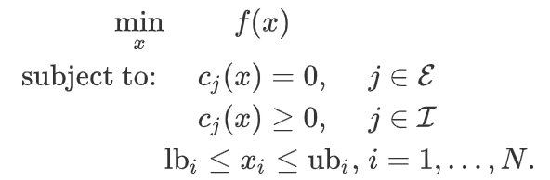

where “E” and “I” are sets of indices containing equality and inequality constraints.

The function we aim to minimize would be the sum of the variance and penalty, between the boundary of 0 and 1 and constraining the sum of weights to be equal to 1. From the above, we then proceed to plot out the efficient frontier. The graph in the appendix (Figure 6) shows expected returns plotted against standard deviation for the portfolio formed between 2005-03-01 to 2006-02-28 of 27 stocks filtered from above.

From the entire North American universe of stocks, mean-variance optimization only chooses 2 stocks, namely DVCR and DWSN, as both lie on the efficient frontier curve. Other stocks will not be picked as for the same level of risk tolerance, an investor is able to invest in stocks with higher expected returns.

This leads us to the limitations of mean-variance optimization. First, the mean-variance framework does not capture other aspects that investors may care about like downside risk. Second, mean-variance utility does not distinguish between gains and losses. This conflicts with the loss-aversion concept in behavioural economics that most investors often feel the pain of losses more acutely than the satisfaction they receive from gains. Therefore, the utility from losing a dollar versus gaining a dollar is rather asymmetrical from what the mean-variance framework posits. Third, from figure 5 in the appendix, the diversification of non-systematic risk of a firm has been greatly curtailed when we attempt to use mean-variance to form a portfolio. Hence, we can see that mean-variance fails to have practical uses in portfolio formation. Fourth, mean-variance optimisation is very sensitive to inputs, such as estimates of expected returns and variances. It may be difficult to measure the true expected returns and variances of stocks, especially small-cap stocks, only over the course of one year.

### *Maximising Sharpe Ratio Utility Function*

Due to the poor diversification in our mean-variance portfolio formation that results in wide fluctuations in returns, we have chosen a secondary way of choosing the weights of stocks. Instead of minimizing variance of the portfolio, we attempt to maximise the Sharpe ratio of the portfolio. The pseudo-code of our methodology can be seen here:

Sharpe ratio is a more risk-adjusted metric that helps investors understand their reward potential (Xi, 2018). Sharpe ratio is given by dividing the difference between the mean expected returns of a portfolio and risk-free rate, over the root of the portfolio’s variance. The risk-free rate is assumed to be 0.5%. The result of maximising Sharpe Ratio has proven to be a more profitable model in terms of returns and volatility. However, in the future, the model could be made more stable by optimising other variables, such as downside risk using Sortino ratio.

## C. Back-testing Methodology

Acknowledging the limitations of the k-fold model in relation to financial data, we decided to instead adopt the rolling validation method, which does not destroy the autocorrelation structure and follows the strict chronological order of financial data. We first make several assumptions: First, the Fiscal year of any company ends between 1st April of the previous year to 31st March of the current year. Second, we will provide a 3-month buffer from 31st March to 29th June, by which all annual reports and financial data is to be published, i.e. by 30th June, all financial data should be public.

There will be an annual rebalancing on 30th June, where stocks will be selected based on our selected signals to form our portfolio. We use the ‘Sharpe ratio’ optimisation to allocate weights, after which annual compounded portfolio returns are calculated over a 1-year period. We then compare the portfolio returns over the entire holding period (15 years) to the benchmark.

# 3. Results

From Figure 7 in the appendix, we see that the individual returns have been fluctuating quite wildly, from losses of -30.4% from June 2007 to June 2008 to large gains of 88.1% from June 2016 to June 2017. There may be reasons to explain certain periods of portfolio performance, such as the poor macroeconomic conditions in 2007 to 2009 that resulted in poor or negative growth. However, it is difficult to truly pinpoint specific reasons for the performance of the portfolio for remaining years as there are too many variables, such as the various signals in use or the method of optimising Sharpe ratio to form the portfolio, to consider. It is imperative to also highlight that the future returns in the table above are before transaction fees. We have chosen the comparison indices stated in Figure 8 of the appendix as our respective benchmarks.

By first comparing our portfolio to the S&P 500, we see that our portfolio generates 16% more excess returns per unit of extra risk than the S&P 500. However, S&P 500 fares better in other areas. Our group has deduced that a possible reason for this is because the majority of our portfolio is made up of small-cap stocks due to their growth potential and relatively higher Sharpe ratio. However, small-cap stocks are often considered to be more volatile as they do not have the resources of the large-cap firms. This makes small-cap companies more vulnerable to negative events or bearish sentiments. On the contrary, the S&P 500 index is market-cap weighted, which means that the larger companies take up the majority proportion of the index. Large companies tend to have larger cash balances to weather through difficult economic times by buying back shares or investing heavily in R&D that will promote future growth. Therefore, this makes the S&P 500 more resistant towards downside risk.

To provide a more well-rounded and suitable comparison, we decided to adopt small cap indices, such as the iShares Core S&P Small Cap ETF (IJR) as well as the Russell 2000 Index, where the latter is a small-cap stock market index of the smallest 2,000 stocks in the Russell 3000 Index. This is because our strategy includes a signal to filter for the smallest stocks. By looking at our Sharpe ratio, we once again observe that our portfolio outperforms in terms of returns per unit of risk while our Sortino ratio seems to be underperforming. This leads us to a possible limitation of our strategy. Given that our allocation of weights is based on “Sharpe-Ratio” optimisation, it has in fact achieved what it set out to do, but has not reached the same level of accomplishment in terms of diversification. We see that IJR’s high Sortino ratio could be due to its low downside standard deviation, which could additionally be because of how it tends to avoid the most illiquid small-cap stocks during rebalancing, thus ameliorating the ETF of illiquidity risks. In addition, both these small-cap benchmarks look to be largely diversified in terms of GICS sectors, with the IJR’s largest weight allocation residing in Industrials.

# 4. Recommendations

Sentiment Analysis

To observe how value stocks perform in relation to varying states of market optimism and pessimism, we carried out a correlation test of market sentiment scores, which were extracted by using text analytics on our portfolio’s return.

In our first step, we collected major news that have affected the financial markets from 2005-2017. We then proceeded to translate the collected information into sentiment scores using sentiment packages from the Python library. Negative scores indicate market pessimism and vice versa. To optimise the best aspects of both packages, we have opted to take the average of both the generated Vadar and Textblob scores. With our obtained scores, we then correlated it with our annual returns to understand the relationship between market sentiment and returns of a set of value stocks. The correlation results show that both variables exhibit an inverse relationship, with correlation scores of -0.341562 (Figure 14). A weak negative correlation score suggests that value stocks tend to exceed market performance in a pessimistic market (bearish state), but fail to perform as well as other stocks in bull markets.

The simple correlation test above shows that sentiment indicators can be used to give signals to traders as to when to enter and exit the market if they are holding on to value stocks. Building on from this, traders could, or are perhaps already using disaggregated sentiment scores of industry-specific news to better allocate the weights of their portfolio so as to reap higher alpha.

# References

Bond, C. (2013, January 8). The 10 Biggest Financial News Stories Of 2012. Retrieved from <https://www.businessinsider.com/biggest-financial-news-stories-of-2012-2013-1?IR=T>

Carlson, R. (2019, November 20). The Top 10 Biggest World Financial Events of the Years 2000 to 2009. Retrieved from <https://www.thebalancesmb.com/top-10-financial-events-of-the-decade-393162>

Carson, R. (2019, January 2). A Look Back At 10 Of The Top Financial News Stories Of 2018. Retrieved from https://www.forbes.com/sites/rcarson/2018/12/23/a-look-back-at-10-of-the-top-financial-news-stories-of-2018/#49648284bd1d

Ganti, A. (2020, March 4). Efficient Frontier. Retrieved March 31, 2020, from <https://www.investopedia.com/terms/e/efficientfrontier.asp>

IJR iShares Core S&P Small-Cap ETF. (n.d.). Retrieved March 31, 2020, from <https://www.etf.com/IJR#overview>

iShares Core S&P Small-Cap ETF. (2020). Retrieved March 31, 2020, from <https://www.ishares.com/us/products/239774/ishares-core-sp-smallcap-etf>

Malik, F. M. F. (2019, August 22). Understanding Efficient Frontier. Retrieved March 31, 2020, from https://towardsdatascience.com/understanding-efficient-frontier-46f1a429d526

Markowitz, H. (1952). Portfolio Selection. The Journal of Finance, 7(1), 77–91. Retrieved from <https://www.math.ust.hk/~maykwok/courses/ma362/07F/markowitz_JF.pdf>

Optimization (scipy.optimize). (n.d.). Retrieved March 31, 2020, from https://docs.scipy.org/doc/scipy/reference/tutorial/optimize.html

Sattar, M. (2017). CAPM Vs Fama-French Three-Factor Model: An Evaluation of Effectiveness in Explaining Excess Return in Dhaka Stock Exchange.

Xi, T. (2018, October 20). Advantages & Disadvantages of Using Sharpe Ratio. Retrieved March 31, 2020, from <https://pocketsense.com/advantages-disadvantages-using-sharpe-ratio-5979.html>

(n.d.). Retrieved from https://www.bloomberg.com/news/articles/2019-07-19/u-s-consumer-sentiment-firms-on-best-financial-view-since-2004

Fama, E. F., & French, K. R. (1992). The Cross-Section of Expected Stock Returns. *The Journal of Finance, Vol. 47, No.2.*, 427-465.

Novy-Marx, R. (2013). The other side of value: The gross profitability premium. *Journal of Financial Economics*, 1-28.

Piotrowski, J. D. (2000). Value Investing: The Use of Historical Financial Statement Information to SeparateWinners from Losers. *Journal of Accounting Research, Vol. 38, Supplement: Studies on AccountingInformation and the Economics of the Firm*, 1-41.

# Appendix

|  |  |  |
| --- | --- | --- |
| Signal | Description | Score |
| F_ROA | Net Income before extraordinary items/begin. of year Total Assets | 1 if positive |
| F_DROA | Change in ROA from previous year | 1 if ROA increases |
| F_CFO | Cash Flow from Operations / begin of year Total Assets | 1 if positive |
| F_ACCRUAL | Net Income before extraordinary items – Cash Flow from | 1 if negative |
| F_DMARGIN | Change in Gross Margin Ratio from previous year | 1 if Gross Margin increases |
| F_DTURN | Change in Asset Turnover (Total Sales/begin. of year Total Assets) from previous year | 1 if Asset Turnover increases |
| F_DLEVER | Change in Long-term Debt/ Ave. Total Assets from previous year | 1 if Leverage decreases |
| F_DLIQUID | Change in Current Ratio from previous year | 1 if Liquidity increases |

**Figure 1: F-Score**

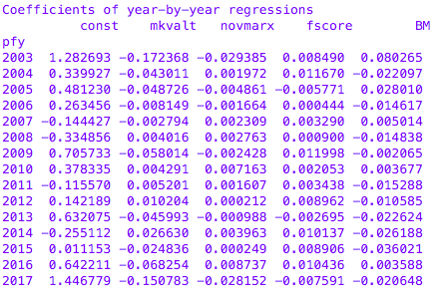**Figure 2: Coefficients of Year-by-Year regressions**

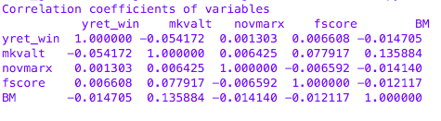**Figure 3: Correlations Coefficients**

**Figure 4:** t-stat/p-values of Regression Coefficients

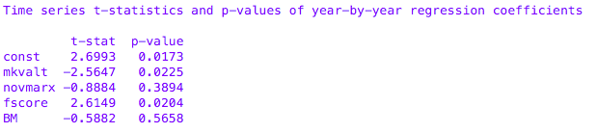

**Figure 5:** Mean-Variance Efficient Frontier

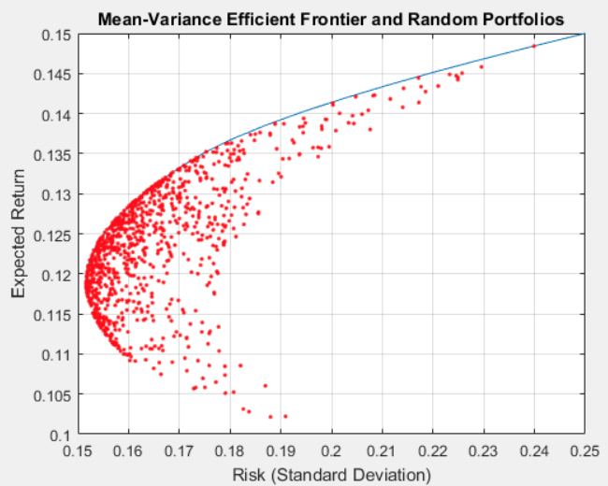

**Figure 6:** Expected Returns against Risk Tolerance of an Investor

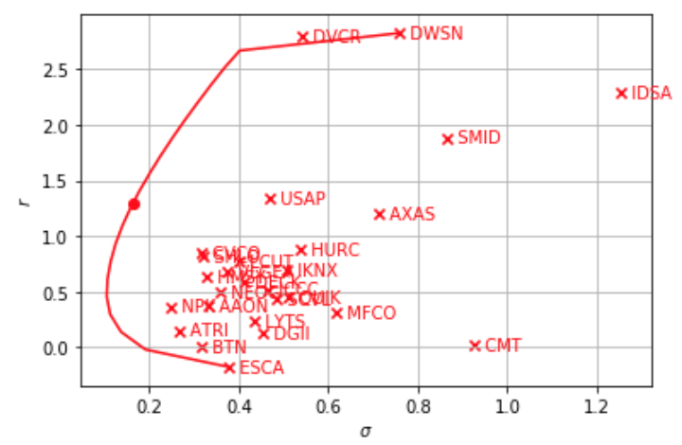

**Figure 7:** Table of Annual Returns based on Portfolio Price

|  |  |  |  |  |  |  |  |  |  |  |  |  |  |
| --- | --- | --- | --- | --- | --- | --- | --- | --- | --- | --- | --- | --- | --- |
| Year | ‘05 | ‘06 | ‘07 | ‘08 | ‘09 | ‘10 | ‘11 | ‘12 | ‘13 | ‘14 | ‘15 | ‘16 | ‘17 |
| Ret% | 75.4 | 20.8 | -30.4 | 6.94 | -16.3 | 38.2 | -11.6 | 51.4 | 62.0 | -14.4 | 8.99 | 88.1 | 19.9 |

ie. ‘05 year refers to backtesting period of June 2005 to June 2006

**Figure 8:** Table of Comparison of Performance Metrics

|  |  |  |  |  |
| --- | --- | --- | --- | --- |
| Type of Index/ Portfolio | Sharpe ratio | Sortino ratio | Max Drawdown | Max Drawdown Duration |
| Our Group’s Portfolio | 68.72% | 56.91% | 66.12% | 17 months |
| S&P 500 | 52.97% | 238.27% | 52.56% | 16 months |
| Russell 2000 | 48.79% | 223.87% | 54.08% | 21 months |
| iShares Core S&P Small Cap ETF | 41.09% | 271.97% | 51.97% | 21 months |

**Figure 9:** Portfolio Growth over the 13-year period

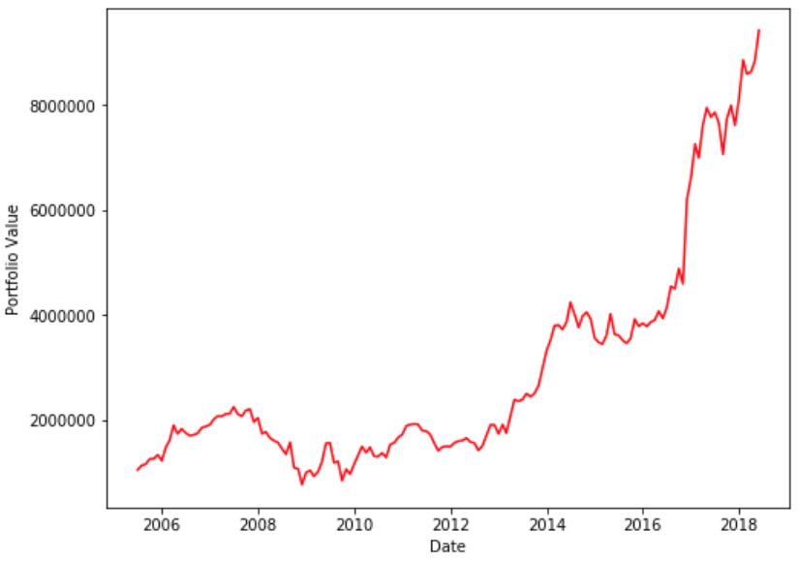

**Figure 10:** Comparison with other Benchmarks over 13-year Period

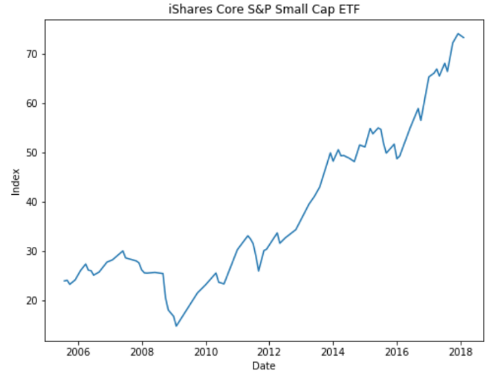

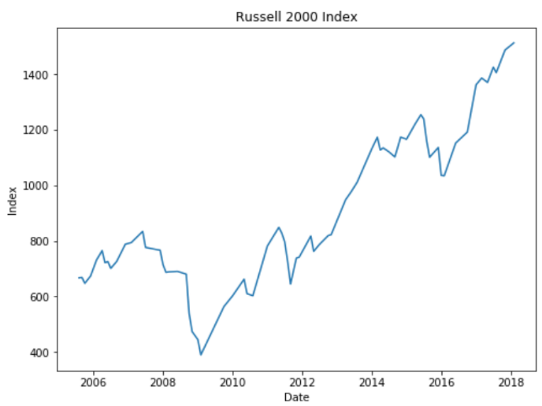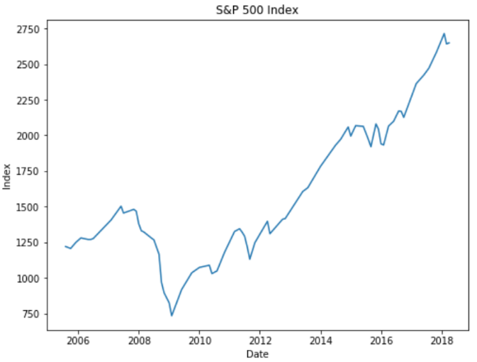

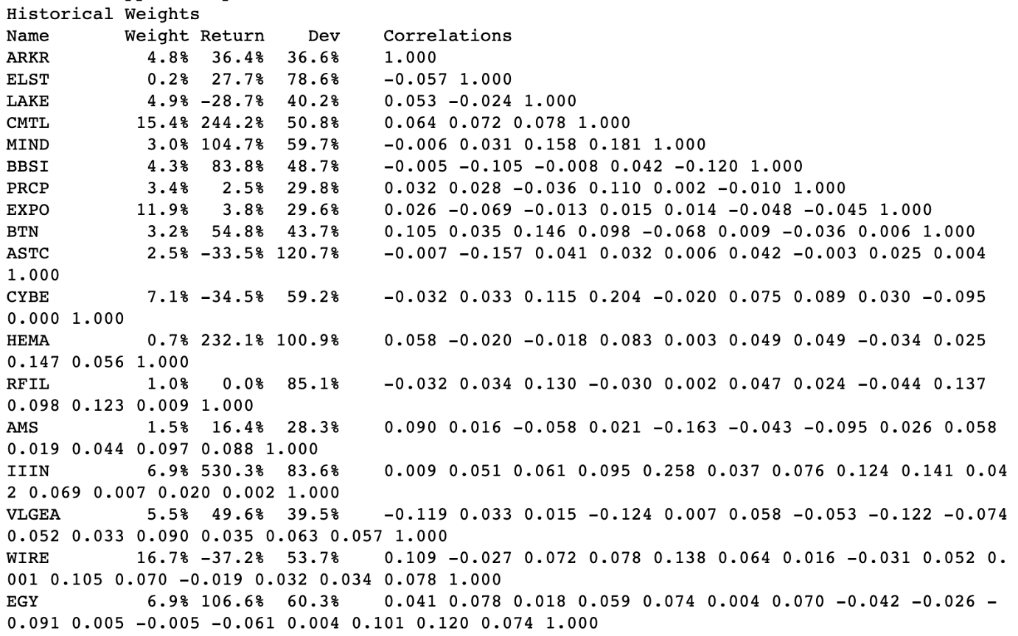**Figure 11:** Correlation Matrix of Stock Pairs before Mean-Variance Optimisation from June 2005 to June 2006

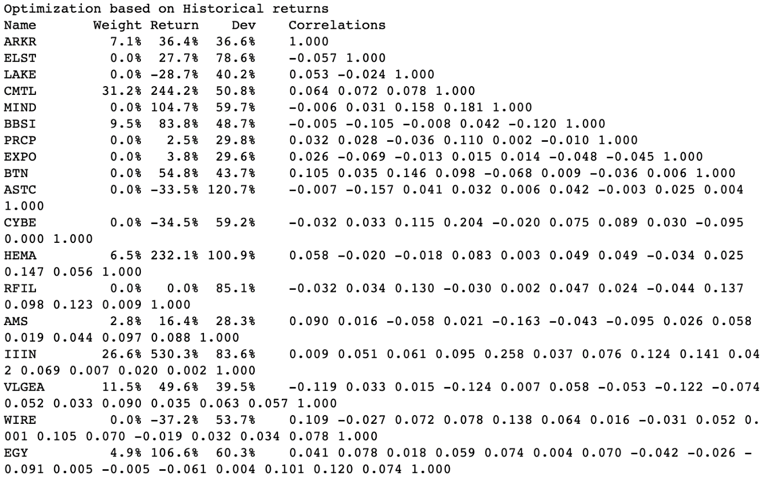**Figure 12:** Correlation Matrix of Stock Pairs after Mean-Variance Optimisation from June 2005 to June 2006

**Figure 13:** Efficient frontier of our sample portfolio

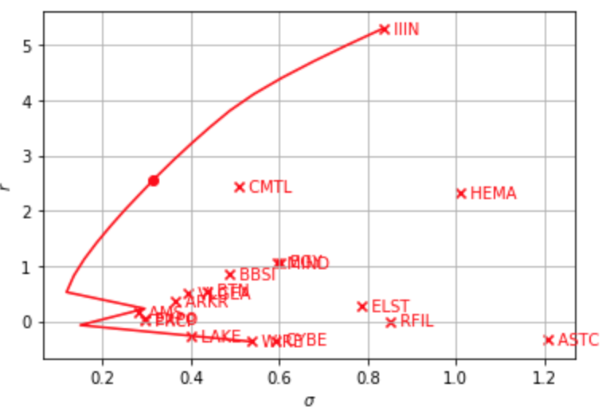

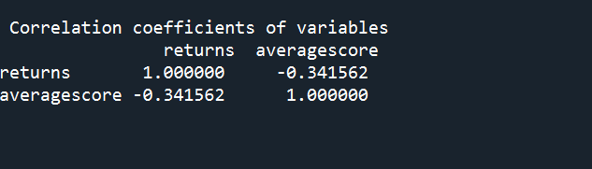**Figure 14:** Sentiment Scores Correlation With Annual Returns